11.3 Neutralization
Name: ____________________ Class: ____________________ Due date:
1. The diagram shows the reaction between zinc oxide and dilute hydrochloric acid.
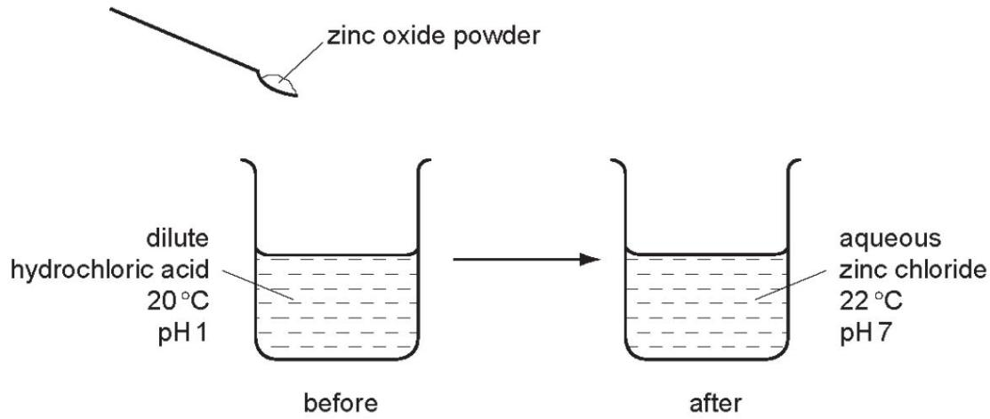
Which terms describe the reaction?
 | endothermic | neutralisation
A | ✓ | ✓
B | ✓ | ×
C | × | ✓
D | × | ×

7. Dilute hydrochloric acid is added to a solid, S.
A flammable gas, G, is formed. Gas G is less dense than air.
What are S and G?
 | solid S | gas G
A | copper | hydrogen
B | copper carbonate | carbon dioxide
C | zinc | hydrogen
D | zinc carbonate | carbon dioxide

13. Some reactions involving sodium are shown.
Which reaction does not involve the formation of a base?
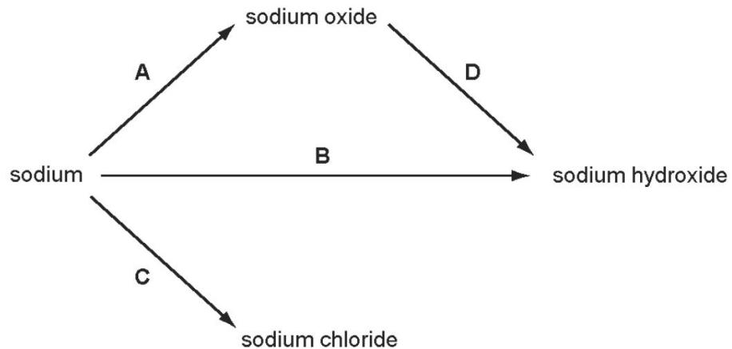

The diagram shows two substances, X and Y, being heated together.
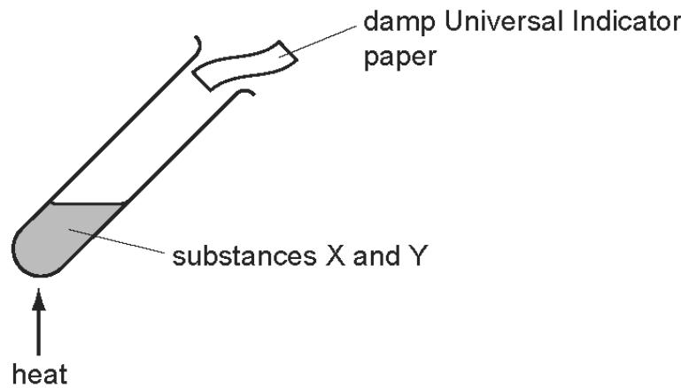
The Universal Indicator paper turns blue during the experiment.
What are substances X and Y?
A ammonium nitrate and hydrochloric acid
B ammonium nitrate and sodium hydroxide
C sodium carbonate and hydrochloric acid
D sodium carbonate and sodium hydroxide

Which statement about the reaction of acids is correct?
A They react with ammonium salts to form a salt and ammonia only.
B They react with metal carbonates to give a salt and carbon dioxide only.
C They react with metal hydroxides to give a salt and water only.
D They react with metals to give a salt, hydrogen and water only.

The diagram shows an experiment.
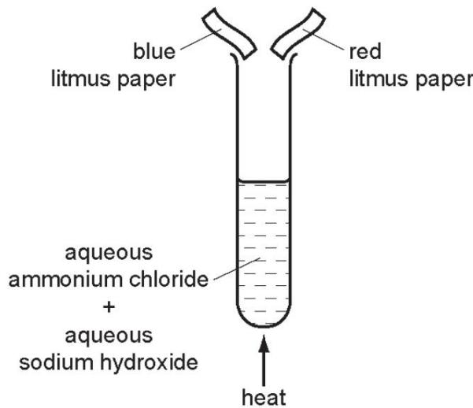
What happens to the pieces of litmus paper?
 | blue litmus paper | red litmus paper
A | changes colour | changes colour
B | changes colour | no colour change
C | no colour change | changes colour
D | no colour change | no colour change

Which are properties of an acid?
1 reacts with ammonium sulfate to form ammonia
2 turns red litmus blue
 | 1 | 2
A | ✓ | ✓
B | ✓ | ×
C | × | ✓
D | × | ×

Which statements about alkalis are correct?
1 When reacted with an acid, the pH of the alkali increases.
2 When tested with litmus, the litmus turns blue.
3 When warmed with an ammonium salt, ammonia gas is given off.
A 1, 2 and 3 B 1 and 2 only C 1 and 3 only D 2 and 3 only

Which method can be used to obtain ammonia from ammonium sulfate?
A Heat it with an acid.
B Heat it with an alkali.
C Heat it with an oxidising agent.
D Heat it with a reducing agent.

Which reaction is not characteristic of an acid?
A It dissolves magnesium oxide.
B It produces ammonia from ammonium compounds.
C It produces carbon dioxide from a carbonate.
D It produces hydrogen from zinc metal.

Which of the following methods are suitable for preparing both zinc sulfate and copper sulfate?
1 Reacting the metal oxide with warm dilute aqueous sulfuric acid.
2 Reacting the metal with dilute aqueous sulfuric acid.
3 Reacting the metal carbonate with dilute aqueous sulfuric acid.
A 1 and 2 only B 1 and 3 only C 2 and 3 only D 1, 2 and 3

Which property is not characteristic of a base?
A It reacts with a carbonate to form carbon dioxide.
B It reacts with an acid to form a salt.
C It reacts with an ammonium salt to form ammonia.
D It turns universal indicator paper blue.

Which statements are properties of an acid?
1 reacts with ammonium sulfate to form ammonia
2 turns red litmus blue
 | 1 | 2
A | ✓ | ✓
B | ✓ | ×
C | × | ✓
D | × | ×

. Hydrogen chloride gas reacts with water to produce an acidic solution. The equation for the reaction is shown.
$$HCl+H_{2}O→{Cl}^{−}+H_{3}O^{+}$$
Which statement describes what happens during the reaction?
A The chloride ion is formed by accepting an electron from the water.
B The hydrogen chloride loses an electron to form the chloride ion.
C The water accepts a proton from the hydrogen chloride.
D The water donates a proton to the hydrogen chloride.

Four substances, P, Q, R and S, are tested as shown.
test | substance
test | P | Q | R | S
dilute hydrochloric acid added | gas given off which 'pops' with a lighted splint | gas given off which turns limewater milky | no reaction | no reaction
dilute aqueous sodium hydroxide added and warmed gently | no reaction | no reaction | gas given off which turns damp, red litmus paper blue | no reaction
What are P, Q, R and S?
 | P | Q | R | S
A | Mg | Na₂CO₃ | NH₄Cl | NaCl
B | Mg | NH₄Cl | Na₂CO₃ | NaCl
C | Mg | Na₂CO₃ | NaCl | NH₄Cl
D | Na₂CO₃ | Mg | NaCl | NH₄Cl

Which statements about a weak acid, such as ethanoic acid, are correct?
1 It reacts with a carbonate.
2 It does not neutralise aqueous sodium hydroxide solution.
3 It turns red litmus blue.
4 It is only partially ionised in aqueous solution.
A 1 and 2 B 1 and 4 C 2 and 3 D 3 and 4

Chloric(I) acid, HClO, is formed when chlorine dissolves in water. It is a weak acid.
What is meant by the term weak acid?
A It contains fewer hydrogen atoms than a strong acid.
B It is easily neutralised by a strong alkali.
C It is less concentrated than a strong acid.
D It is only partially ionised in solution.

What is not a typical characteristic of acids?
A They react with alkalis producing water.
B They react with all metals producing hydrogen.
C They react with carbonates producing carbon dioxide.
D They turn blue litmus paper red.

Three solids, P, Q and R, all react with dilute sulfuric acid to produce zinc sulfate.
P and R produce gases during the reaction.
The gas produced when P reacts will not burn.
The gas produced when R reacts will burn.
What are P, Q and R?
 | P | Q | R
A | zinc | zinc hydroxide | zinc carbonate
B | zinc carbonate | zinc | zinc oxide
C | zinc carbonate | zinc hydroxide | zinc
D | zinc oxide | zinc carbonate | zinc

Compound P reacts with hydrochloric acid to produce a gas that turns limewater milky.
What is P?
A sodium carbonate B sodium chloride C sodium hydroxide D sodium sulfate

Which statement about acids and bases is correct?
A A base is a donor of hydrogen ions.
B An acid is an acceptor of protons.
C A strong acid is fully ionised in aqueous solution.
D A weak acid cannot be used to neutralise a strong base.

When dilute sulfuric acid is added to solid X, a colourless solution is formed and a gas is produced.
What is X?
A copper(II) oxide B sodium oxide C copper(II) carbonate D sodium carbonate

Solution Q is warmed with ammonium chloride.
In a separate experiment, solution Q is added to methyl orange.
Which observations show that solution Q is basic?
 | warmed with ammonium chloride | added to methyl orange
A | gas is produced | turns red
B | gas is produced | turns yellow
C | no reaction | turns red
D | no reaction | turns yellow

Which statements about dilute sulfuric acid are correct?
1 It turns red litmus paper blue.
2 It reacts with magnesium(II) oxide to form magnesium(II) sulfate and water.
3 It reacts with magnesium to form magnesium(II) sulfate and carbon dioxide.
4 Its pH is below pH 7.
A 1 and 2 only B 1 and 3 only C 2 and 4 only D 3 and 4 only

Which statement describes a weak acid?
A It is a proton acceptor and is fully ionised in aqueous solution.
B It is a proton acceptor and is partially ionised in aqueous solution.
C It is a proton donor and is fully ionised in aqueous solution.
D It is a proton donor and is partially ionised in aqueous solution.

What is a characteristic of acids?
A Acids turn methyl orange indicator yellow.
B Acids have a high pH value.
C Acids react with ammonium salts to give ammonia gas.
D Acids react with carbonates to produce salts.

